**East Intermediate Menu 2024-25**

**Milk Choice Available Daily**

**Menu subject to change without notice Cooler Daily Specials: Chef Salad, Taco Salad, Spicy**

**This institution is an equal opportunity provider Chicken Salad, Turkey, or Ham Salad**

**Breakfast: cereal bar, frudel stick, cereal bar kit, fruit bread slice, pancakes**

**Including juice, fresh fruit, and milk**

**Students must take a fruit and/or vegetable/juice with their meal**

***Hotdog/Hamburger Bar***

***Fries or Tator Tots***

***Soup***

***Variety of Vegetable Toppings***

***Pizza***

***Italian Bar***

***Spaghetti with Meat Sauce***

***Chicken Alfredo***

***Macaroni & Cheese***

***Garlic Toast***

***Bosco Stick with sauce***

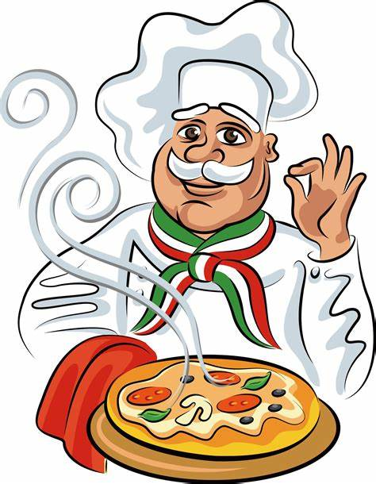

***To go Salads, subs, wraps***

***Chicken Sandwich***

***Chicken Nuggets/Tenders***

***Featured Bowls***

***Popcorn Chicken***

***Creamy Mashed Potatoes***

***Golden Corn***

***Gravy***

***Shredded Cheese***

***Stir Fry***

***Orange Chicken***

***Teriyaki Chicken***

***Brown Rice***

***Stir Fry Vegetables***

***Fortune Cookie***

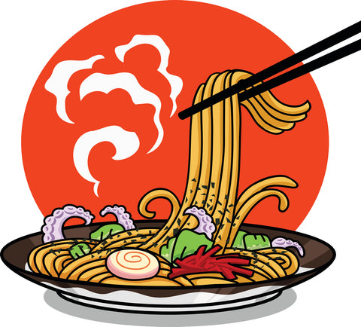

***Taco Bar***

***Wet Burritos***

***Taco Meat***

***Fajita Chicken***

***Cheese Sauce***

***Queso***

***Tortilla Chips***

***Refried/Black Beans***

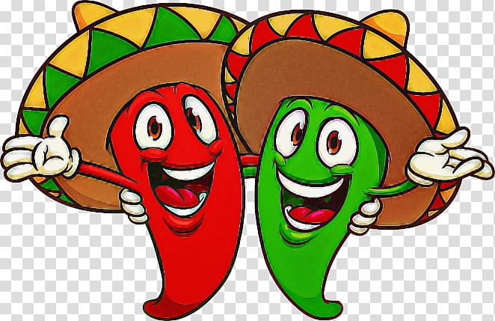

**Friday**

**Monday**

**Wednesday**

**Thursday**

**Daily Specials**

**Tuesday**

***Breakfast***

**Fresh fruit and vegetable bar available daily**

**Breakfast and lunch free to all students.**